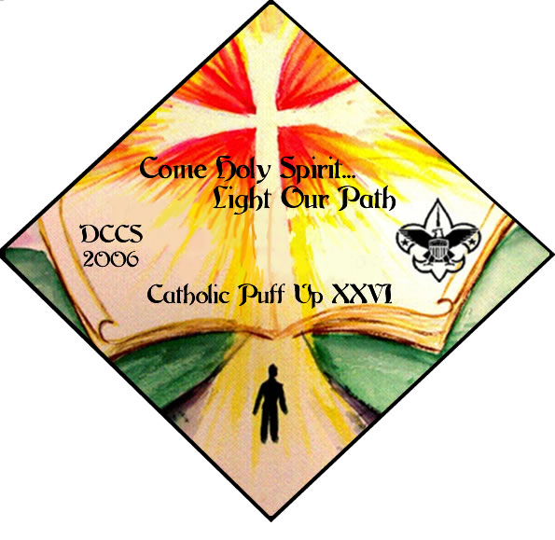

September 30 Family Camping available on Friday and Saturday at Cubworld

Puff Up Activity is on September 30 from 7:30 am – 3:25 pm

Fee is $ 5 per person
Register on line Starting August 25 until September 22.
Register as a Pack or Individually
Limited Space register Early !
Register online at www.dccs-dgh.org

Many fun games and craft activities planned for the families and Special Archery Program for Webelos Only !!
Saturday Program
Check In Starts at 7:30am – 8:15am
Opening 8:15 - 8:30
Activities from 8:30am – 3:25pm

Mass at 4:00 pm

You can camp on Friday night and/or Saturday Night
Check in on Friday after 5pm and Check Out is Sunday at Noon
Need more info email Puffup2006@yahoo.com
Or Call Helen Soto after 2pm at 281-799-1094

